DOCUMENTATION OF STRUCTURES PROPOSED FOR DEMOLITION IN SUPPORT OF THE PARK’S GREAT AMERICAN OUTDOORS ACT (GAOA) LEGACY RESTORATION FUNDED FACILITY INVESTMENT PLANNING PROJECT, NEW RIVER GORGE NATIONAL PARK AND PRESERVE

Historic Resource Survey Final REPORT
NERI 237369
A Report Submitted to the National Park Service in Accordance with the Provisions of NPS Contract No. 140P2022F0114
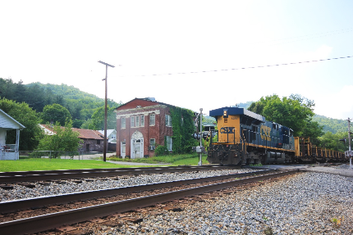
November 10, 2022


prepared by
and


1436 Graham Road
Silver Lake, OH 44224
Phone: (304) 685-7410
23939 SW Gage Road
Wilsonville OR 97070
Phone: (503) 473-8477

Historic Resource Survey of the New River Gorge National Park

Contents
MANAGEMENT SUMMARY 1
INTRODUCTION 2
PURPOSE 1
Project Area Description 1
Historic Context 1
European American Settlement and Agriculture 2
Railroad Industry 2
Coal Industry 4
Joseph L. Beury 4
John Nuttall 4
Thomas G. McKell 5
New River Gorge National Park and Preserve 7
Development of Recreation and Tourism Industry 7
Grandview State Park 7
Camp Brookside, Summers County 9
Creation of the New River Gorge National River 9
New River Gorge National River 10
Recreational Opportunities 10
Cultural Resources 11
Whitewater Industry 11
Communities Within the Project Area 12
Hinton 12
Prince 12
Thurmond 12
Fayetteville 13
Survey METHODOLOGY 13
Survey Preparation 13
Literature Review 13
Survey Database 14
Mapping 14
Field Survey 14
Evaluation 16
Survey conclusions 21
Thurmond Historic District Field Observations and Recommendations 21
Long-Term Management Strategies 21
Immediate and Medium-Term Interventions 22
Maintenance Plans and Training 22
Evaluation of Specific Resources in the Historic District 23
Conclusions 30
Bibliography 30
Appendix A 0
Appendix B 0
Appendix C 0
Appendix D 0

MANAGEMENT SUMMARY
The New River Gorge National River was created in 1978 and was designated as the New River Gorge National Park and Preserve in 2021. It stretches for 53 miles from Hinton to Fayetteville through Summers, Raleigh and Fayette Counties. The park’s boundaries include former coal mining and railroad towns, farms, camps, campgrounds, and three state parks. The New River, one of the world’s oldest rivers, flows in a northward direction from western North Carolina to West Virginia, forming the New River Gorge, an area of dramatic landscapes and center of outdoor tourism.
The National Park Service (NPS) – New River Gorge National Park and Preserve (NERI) received funding under the Great American Outdoors Act Legacy Restoration Fund of 2020 for park improvements. A list was compiled by NERI staff of 41 structures, consisting of 20 Non-Historic and 21 Historic properties that are candidates for demolition under this funding award. Any potential effects to Federally-owned historic structures require survey, evaluation and review under Sections 106 and 110 of the National Historic Preservation Act. The project team of Bratslavsky Consulting Engineers, Inc. (BCE) and Aurora Research Associates LLC (ARA) was selected to perform an historic resource survey and National Register evaluation of the 41 structures, as well as historic preservation recommendations for those and an additional 13 structures within the Thurmond Historic District. The historic resource survey was conducted in accordance with the West Virginia State Historic Preservation Office’s (WVSHPO) National Register and Architecture/History Survey Manual (June 1, 2016 draft).
ARA conducted the field survey in June 2022 and completed 32 West Virginia Historic Property Inventory (HPI) forms encompassing 35 structures. Seven properties were found to already have been demolished. Three historic properties had previously been listed or determined eligible for listing in the National Register of Historic Places (NRHP). An additional five properties were determined to be potentially eligible for the NRHP. The remainder of the surveyed properties were determined to be ineligible for the NRHP due to age, lack of significance and/or lack of integrity.
ARA also field documented 13 contributing resources within the Thurmond Historic District. The significance of these resources has already been established since they are part of the historic district. The majority of these resources were found to retain integrity but were in need of basic maintenance including vegetation clearing, building envelope repairs and gutter cleaning/repair. The Billy McGuffin Garage and Phillip A. McClung House are the most likely candidates for demolition based on lack of significance and integrity. The Erskine Pugh Rental House is also in poor condition; Sections 110 and 106 coordination for its demolition has already been completed.
Preservation/stabilization is recommended for the remainder of the buildings, starting with immediate repairs to keep water, vegetation, trespassers and animals out of the structures. In addition, the establishment of a routine maintenance plan, staff training in preservation techniques and a comprehensive management plan are recommended for long-term stewardship of the Thurmond National Register Historic District and any other listed or eligible structures within park boundaries.

INTRODUCTION
The New River Gorge National Park and Preserve (NERI) received funding under the Great American Outdoors Act Legacy Restoration Fund for park improvements that may include demolition of structures over 50 years of age, requiring evaluation and review under Section 106 and Section 110 of the National Historic Preservation Act. NPS/NERI engaged Bratslavsky Consulting Engineers (BCE) and Aurora Research Associates (ARA) to conduct an historic resource survey and determinations of National Register of Historic Places (NRHP) eligibility for 54 structures owned by the park including 20 Non-Historic properties expected not to meet the National Register age, significance and/or integrity criteria, 21 Historic properties with potential to meet National Register eligibility requirements and 13 structures within the Thurmond Historic District. were included in the project scope to ensure that Section 106/110 requirements were met prior to demolishing any structure. The properties included in the original scope of services include:

Non-Historic Structures
1. Ajax Mines Grounds
2. Ajax Pump Station Building
3. Billy Jo Adkins House
4. Burnwood Maintenance Storage Building
5. Burnwood Ranger Storage Building
6. Burnwood Ranger Storage Shed
7. Clarence Plumley House Meadow Creek
8. Dun Glen Ark
9. Dun Glen Boat Storage/Emergency Cache
10. Dun Glen Boat Storage Rack
11. Dun Glen House/Dormitory (Powerhouse)
12. Dun Glen Mini Ark
13. Glade Creek Vault Toilet
14. Glenwood Corp. River Road Cabins
15. Grandview Resource Stewardship Office
16. Jonny and Brenda Adkins House
17. Julian Mark Richmond House
18. Julian Mark Richmond Shed
19. Samuel Ames Garage
20. Samuel Ames House

Historic Structures
1. Cochrane Farm Outbuilding #1
2. Cochrane Farm Outbuilding #2
3. Cochrane Farm Grounds
4. Dun Glen Building Ranger Station
5. Harrah Coal House
6. Harrah Hen House
7. Harrah House
8. Harrah Outbuilding #1
9. Harrah Shed #1
10. Harrah Smokehouse
11. Harrah Outhouse
12. James K. Carper Barn
13. James Phillips Farm House (collapsed)
14. James Phillips Farm Outbuilding #1
15. James Phillips Farm Storage #2
16. James Phillips Farm Shed
17. Prince Brothers General Store
18. Camp Brookside Pool Chemical Treatment Building
19. Christiana and James Vallandingham Log Cabin House
20. Christiana and James Vallandingham Storage Building
21. Christiana and James Vallandingham Smokehouse

The scope of work also included field survey and recommendations for the following 13 contributing structures within the Thurmond Historic District. These properties are addressed in the section “Thurmond Historic District Field Observations and Recommendations” beginning on page 21.
- Charles Ashley Garage
- Charles Ashley Outbuilding
- Marilyn Brown House
- Erskine Pugh Rental House
- Harold Smith House
- Ice House (foundation)
- James Humphrey Sr. House
- May Bagoski House
- Billy McGuffin Garage
- Phillip A. McClung House
- Tom Kelly House
- Wedzel Young House
- Sidney Allen Ward House

PURPOSE
In support of the NERI’s Great American Outdoors Act (GAOA) Legacy Restoration Funded (LRF) Facility Investment Planning Project, the purpose of this project is to prepare West Virginia Historic Property Inventory (HPI) Forms for twenty (20) non-historic and twenty-one (21) historic structures located within the confines of NERI. Documentation of the federally-owned structures will provide NERI with the baseline information necessary to further the advancement of the proposed demolition of the structures to improve the park’s overall safety, operations, and financial sustainability.
This project supports Section 106 and Section 110 of the National Historic Preservation Act of 1966 (16 USC 470h-2(a)(1)) and the mission of the West Virginia Department of Arts, Culture and History, West Virginia State Historic Preservation Office (WVSHPO), by the identification and documentation of properties that are potentially eligible or ineligible for listing in the National Register of Historic Places.

Project Area Description
The New River Gorge National River was created in 1978 and was designated as the New River Gorge National Park and Preserve in 2021. It stretches for 53 miles between Hinton in Summers County and Fayetteville in Fayette County. The park’s boundaries include former coal mining and railroad towns, farms, camps, campgrounds, and three state parks. Important transportation routes include the New River, CSX Railroad, Interstates 77 and 64, and WV Routes 19 and 20. The New River, the world’s second oldest rivers, flows in a northward direction from western North Carolina to West Virginia. It joins the Greenbrier River in Hinton, Summers County and flows through Raleigh and Fayette County where it joins with the Gauley River to form the Kanawha River.

Historic Context
This section provides an overview of the history of the New River Gorge National Park and Preserve with particular focus on the historic contexts relevant to the resources in the survey. For in-depth extensive histories of the Park and surrounding areas, refer to New River Gorge National River Administration History by Gregory A. Good and Lynn Stasick (2008) and New River Gorge National River Special History Study/Historic Context Study by Harlan D. Unrau (1996).

European American Settlement and Agriculture
Prior to European exploration and settlement, Indigenous peoples occupied the New River region for at least twelve thousand years. These groups included the Delaware, Shawnee, Tutelo, Saponi, Mingo and Cherokee. A number of trails traversed the New River region, including the Midland Trail, roughly followed by US Route 60 today. During the colonial period, early European explorers and settlers utilized these routes to expand into the undeveloped frontier. The English Crown and later the Commonwealth of Virginia granted large tracts of land in the present-day New River Gorge region to veterans of the French & Indian and Revolutionary Wars.
The first European settlers were of English, Scotch-Irish, and German descent and they relocated from eastern Virginia and Pennsylvania. Peter Bowyer was the first documented settler at the junction of Manns Creek and the New River near present day Fayetteville. Other settlers soon followed: Andrew Lykens near Page, John Spangler in Kincaid, Abraham Vandal in Fayetteville, Jacob Smith in Quinnimont, Alfred Beckley in Beckley, Philip Thurmond in Minden, and William Richmond at Sandstone Falls in Summers County.
Between the late 1700s and mid-1800s, farming was the primary industry in present-day Fayette, Raleigh, and Summers counties. Early settlers established farms near the fertile banks of the New River and adjacent creeks after the Revolutionary War. This area was remote and isolated from communities in eastern Virginia. Upon arrival, settlers cleared land for growing crops including corn, buckwheat, oats, and wheat, raised livestock, and constructed log-cabins. Their livelihood depended upon subsistence farming, hunting, and fishing. Settlers utilized game for food and clothing.
The economies of Fayette, Raleigh, and Summers County were agriculture-based until the arrival of the Chesapeake & Ohio Railroad.

Railroad Industry
The existence of coal in present-day West Virginia was well known in the mid-to-late 1700s and early 1800s. However, transporting the coal to eastern markets was not possible due to difficult mountain terrain and lack of suitable transportation routes. The construction of the railroad from the Atlantic Ocean to present-day West Virginia opened the area to development. In 1836, the Virginia General Assembly chartered the Louisa Railroad, the predecessor to the Virginia Central, to carry farm products to market. By 1850, the mainline had reached Charlottesville, Virginia and was renamed the Virginia Central Railroad. The Virginia General Assembly chartered a second railroad, the Covington & Ohio, to construct a line over the Allegheny Mountains from Covington to the Ohio River. Work on this line was stopped during the Civil War and construction resumed afterwards.

The Chesapeake and Ohio Railroad (C&O) was the first railroad in southern West Virginia and opened the New River Gorge region to economic development. It was created in 1869 when the Covington & Ohio Railroad and Louisa Railroad merged with the purpose of establishing a transportation route from the Atlantic Ocean to the Ohio River. This merger attracted the financial backing of Collis P. Huntington and with his support construction of the C&O Railroad quickly progressed. Construction of the C&O mainline began from each end, Huntington to the west & Covington to the east, and met in the middle at Hawks Nest in Fayette County. Its route followed along the Greenbrier, New, and Kanawha Rivers. African Americans from Virginia, North Carolina, and other southern states were recruited to construct the line. Materials for the railroad line were transported by wagons or floated down the river in bateaux. In 1872, the C&O Railroad arrived in present-day Hinton in Summers County. From Hinton, construction of the Chesapeake & Ohio mainline continued on the northern side of the New River. It reached Fayette County the following year.

With construction underway, speculators began purchasing land along the future C&O Railroad mainline. Coal operators Joseph L. Beury and John Nuttall opened the first two coal mines in Fayette County at Quinnimont and Nuttalburg. In 1873, the coal from Beury’s Quinnimont mine was the first to be shipped on the Chesapeake & Ohio Railroad. Another speculator, businessman William Prince purchased a large tract of land from General Alfred Beckley in anticipation of the railroad’s arrival. Prince established a business in present-day Prince that catered to the workers’ needs.

In the 1890s, the Chesapeake & Ohio Railway acquired existing branch lines from coal operators and constructed new branch lines to connect the coal mines and timber industry to the mainline. In 1894, the Loup Creek Branch was completed between Thurmond and Prince. The White Oak Branch (1900), Laurel Creek Branch (1904), and Arbuckle Creek Branch (1904) soon followed. Approximately 20-years after the C&O Railroad arrived in Fayette County, they constructed the first branch line into Raleigh County, opening the county to development. Construction of the 13-mile Piney Creek Branch began in 1898 and was completed in 1901. In 1900, a bridge was constructed at Prince which connected the Piney Creek Branch to the Chesapeake & Ohio mainline. Table 1 summarizes the development of the C&O and its branch lines in the project area.

Line | Construction Date(s) | Towns
C&O Mainline | 1872 | Hinton
 | 1873 | Hawks Nest
Glade Creek and Raleigh | 1891 | Glade Creek
Loup Creek Branch | 1893 | Thurmond to Glen Jean
Piney Creek Branch | 1900-1901 | Piney Creek, Raleigh
White Oak Branch | 1900 | Glen Jean to Carlisle
Laurel Creek Branch | 1904 | Qunnimont to Layland
Arbuckle Creek Branch | 1904 | Minden to Thurmond
Table 1. Timeline of Construction of the Chesapeake & Ohio Line
The development of railroad towns followed the construction of the Chesapeake & Ohio Railroad. Hinton, Thurmond, Quinnimont, Prince, and Fayette/South Fayette developed as railroad towns in the New River Gorge. The Chesapeake and Ohio Railroad purchased land along the mainline in these towns for railroad purposes and constructed passenger stations, freight depots, machine shops, roundhouses and turntables, coaling stations, engine repair shops, and coaling towers on available flat lands. As the number of railroad workers increased, residential and commercial structures soon followed on the remaining flat lands and on hill sides.

The Chesapeake & Ohio Railroad transported coal, freight including timber and agricultural products, and passengers. In the 1950s, the railroad industry began to decline due to the change from steam to diesel locomotives, mine mechanization, and declining coal production in the New River Coalfield. Residents in the New River Coalfield began leaving the area in search of other employment opportunities. The former railroad town Thurmond eventually became a ghost town.

Coal Industry
The arrival of the Chesapeake & Ohio Railroad in 1873 went hand-in-hand with the development of the New River Coalfield in eastern Fayette County and northeastern Raleigh County. The presence of coal in present-day West Virginia was well-known. In 1742, explorer John Peter Salley (Sallings) wrote the first written account concerning coal in present-day Fayette and Raleigh counties. Two surveys conducted between 1835 and 1853 also discussed the available coal deposits in Fayette County. The first survey was conducted by professor and geologist William Barton Rogers who described large deposits of coal and included maps in his report. A survey by English geologist David T. Ansted followed with reports of coal in Fayette County. Ansted also had permission to purchase desirable coal lands.

Following the Civil War, interest in the New River Gorge region coal industry increased. Early land speculators General John Imboden and Allen T. Caperton began promoting the sale of coal lands in Fayette and Raleigh counties both internationally and domestically. By the early 1870s, both men were able to attract the capital needed to open coal mines. Experienced coal miners from Pennsylvania and Great Britain and small coal companies also began purchasing tracts of land near the coal seams. These coal operations were located along the Chesapeake & Ohio mainline with the mine openings located along the hillside. By 1876, there were six coal companies shipping the high quality bituminous “smokeless” coal to markets: the Pennsylvania & Virginia Iron & Coal Company at Quinnimont, Fayette Coal & Coke Company, Fire Creek Coal & Coke Company, Longdale Iron Company, Beury, Cooper, Williams Company, and Nuttalburg Coal & Coke Company.

Joseph L. Beury
Joseph Lawton Beury opened the first coal mine in the New River Coalfield in Fayette County. Born in Schuykill County, Pennsylvania, Beury worked in anthracite coal mines for a number of years before becoming mine superintendent. In 1872, Beury left Pennsylvania and relocated to Fayette County where he established the New River Coal Company. He opened a mine at Quinnimont and supplied coal to the Longdale Iron Company of Allegheny iron furnace. The following year in September 1873, he shipped the first shipment of coal on the Chesapeake & Ohio Railroad from his Quinnimont mine. Beury operated the Quinnimont mine until 1876 when he and associates Jenkin Jones, John Freeman, and Thomas Davis established the Fire Creek Coal & Coke Company also located along the New River. He worked to develop the coalfield until his death in 1904.

John Nuttall
The second coal operator to open a mine along the New River was John Nuttall. In 1849, Nuttall immigrated to the United States from England and settled in Pennsylvania. Nuttall began purchasing land in 1870 along the New River and relocated to Fayette County three years later where he opened his coal mines. His second operation was the Nuttallburg Coal and Coke Company. By 1880, the Nuttallburg Coal & Coke Company was the largest producer of coal in the New River Coalfields.

Thomas G. McKell
Thomas Gaylord McKell (1845-1904) was the third individual to establish a coal company in the New River Coalfields. Born in Ohio, McKell acquired 12,500 acres of land on Dunloup Creek near present-day Thurmond from his father-in-law John Dunn. After hearing about coal being shipped on the C&O Railroad, McKell investigated his land and discovered the valuable coal and timber resources on his property. He then purchased an additional 12,500 acres adjacent to his other tract bringing the total to 25,000 acres. In 1899, McKell constructed a bridge that connected his property with the Chesapeake & Ohio Railroad mainline. The following year, McKell created the McKell Coal and Coke Company and opened the Derryhale, Kilsyth, Oswald, Graham, and Tamroy mines. McKell selected the nearby town of Glen Jean as the center of his coal operation. He named the site Glen Jean in honor of his wife. In 1901, McKell constructed the Dunglen Hotel, a three-story 100-room hotel located across the New River from Thurmond.

In the 1880s, coal and coke production increased as new mines and towns were established. There were 15 mines operating along the Chesapeake & Ohio mainline at Quinnimont, Stone Cliff, Echo, Fire Creek, Sewall, Caperton, Kenneys Creek, Nuttalburg, Fayette Station, Elmo, Sunnyside, Gaymont, Alaska, Claremont, and Central. By 1888, Fayette County was the leader of coal and coke production producing over 1 million tons of coal. Fayette County would remain the leader of coal production until 1904 when it was surpassed by McDowell County.

The development of coal towns soon followed the opening of the coal mines. The layout of coal towns was based on geography. Due to the remoteness of the New River Gorge region, coal companies needed to construct the necessary coal infrastructure and houses for their employees. Coal structures including tipples, coke ovens, blacksmith and carpenter shops were constructed first followed by residences. Residences were located on available land near the mine outcrop and located on the hill side or on available flat land. Homes were constructed of native timbers and had one or two basic floor plans. The coal companies also typically constructed a company store usually built in the center of town, a multi-purpose community center, two schools, and two churches: one for White people and the other for Black people.

As the number of coal mines increased in the New River Coalfield, additional labor was needed to meet the demand. In the late 1800s, southern West Virginia was sparsely populated, and the majority of residents were farmers. In 1880, the population of Fayette County was 11,560 residents and 7,367 residents in Raleigh County. Coal operators sent agents to recruit White miners from other coal fields, Black workers from southern states, and immigrants from southern and eastern Europe. Large numbers of Austrians, Greeks, Hungarian, Italians, Germans, Poles, and Russians immigrated to the New River Coalfields.

By the late 1890s, the New River Coal Field lacked adequate medical facilities to serve residents. In 1899, the West Virginia Legislature passed an act “providing for construction of three hospitals for treatment of ‘persons injured while engaged in employments dangerous to health, life, and limb.’” This act created three miners’ hospitals in the Pocahontas, Fairmont, and New River coal fields. The Miners Hospital No. 2 or McKendree Hospital No. 2 was constructed along the Chesapeake & Ohio mainline at McKendree. Opened in 1901, the McKendree Hospital operated until 1941when it was converted into the West Virginia Home for Aged and Infirm Colored Men and Women.

The coal industry in Raleigh County developed almost 20 years after the first mines opened in Fayette County. In 1891, the Royal Mining Company opened the first coal mine in Raleigh County at Grandview. Coal was transported in buckets attached to cables across the New River to Prince where it was loaded onto train cars and transported to markets. A second coal operation, the Raleigh Coal and Coke Company began operations in 1900. The following year, a branch of the Chesapeake and Ohio Railroad was completed into Raleigh County.

Coal production briefly increased during the early twentieth century peaking in 1916. Over the next two decades, coal production fluctuated and the overall quantity of coal produced declined. A number of coal mines closed while smaller companies merged with larger ones between the 1920s and 1940s. On October 29, 1929, the stock market crashed and the United States entered the Great Depression. By 1932, coal production had dropped and the coal mines closed resulting in many unemployed miners. President Franklin D. Roosevelt’s New Deal program put unemployed men back to work. By 1937, coal production was increasing and it would continue to increase during World War II. The federal government controlled coal production during the war by setting prices, wages, and the market.

After the World War II, changes came to the once booming coal industry. Coal production declined as the demand for coal decreased and the demand for alternative fuels such as oil and natural gas increased. Mine mechanization and new technologies also impacted the coal industry. With the invention of new machines, fewer workers were needed to mine the coal. As a result, unemployed miners and their families left the coalfields in search of new opportunities. Coal mining in the New River Gorge stopped and former coal mining towns have become ghost towns. Remnants of the once thriving coal and railroad industries remain in Thurmond, Nuttallburg, and Kaymoor.

Between the 1870s and 1930s, attempts were made to unionize the southern West Virginia coalfields. The first attempt at unionizing the New River Coalfield took place in 1897 when the Knights of Labor called for the first strike. Coal operators were successful in defeating this strike. In 1890, the United Mine Workers (UMW) was founded to represent workers. There were concerns about the nonunion mines in southern West Virginia and the rising tonnage of bituminous coal flooding the market. Mary Harris “Mother” Jones and John Mitchell led the effort to unionize the southern West Virginia coalfields in 1897; however, coal operators were again able to stop their efforts. The UMW was advocating for increased pay, better working conditions, abolishing the mine guard system, uniform wage scales, recognition of the union, and stopping the blacklisting of union miners. A significant win for the UMW occurred during the Great Depression when President Franklin D. Roosevelt signed the National Industry Recovery Act.

New River Gorge National Park and Preserve

Development of Recreation and Tourism Industry
West Virginia’s recreation and tourism industry emerged following the following the rapid industrialization that took place during the mid-to late 19th century. During this time, various individuals and groups began to recognize the negative impacts of industrialization on the natural environment, giving rise to a conservation era that included the development of protective laws, parks, resorts, summer camps, naturalistic suburbs and other attempts to protect and engage with nature. The industrial development of the New River Gorge area had resulted in depleted coal and timber resources. Rivers and streams were polluted with coal, resulting in a declining fish population; game animals and birds also lost their native habitats. In 1908, the West Virginia State Conservation Commission under geologist Dr. Israel C. White’s leadership prepared the first report describing the destruction of natural resources and the need for conservation. The report also indicated that protecting nature, cleaning and stocking streams, and building roads would attract thousands of tourists to the state.

In 1925, White’s report was followed by another report by the State Forest, Park, and Conservation Committee. This committee investigated the needs and opportunities for forests, parks, and game preserves and made recommendations to the 1927 Legislature. They recommended that “large areas of outstanding scenic and natural attractiveness be secured before commercial exploitation made their purchase difficult. The West Virginia State Parks System was the result of this study and the Great Depression.

When the Great Depression began in 1929, thousands of West Virginians became unemployed. President Franklin D. Roosevelt addressed the problem of unemployment by creating a series of programs known as the New Deal. In March of 1933, Congress passed the first New Deal legislation: the Emergency Work Act which allocated federal funds for the purchase of park lands and created the “Civilian Conservation Corps” or C.C.C. This program put thousands of young men between the ages of 18 and 25 to work in forests and state parks. The enrollees were selected based on familial need and joined camps consisting of approximately 200 men. West Virginia hosted a total of 66 C.C.C. camps between 1933 and 1941. Each camp fought forest fires, planted trees, constructed shelters, trails, roads, and many of West Virginia’s state parks including two parks located within the future boundaries of the New River Gorge National River: Babcock State Park (1937) and Grandview State Park (1939-1940).

During the mid-to-late twentieth century, other recreational activities including camping, hunting, fishing, rock climbing, hiking, biking, and water sports gained in popularity. The New River Gorge region had a longstanding tradition of hunting and fishing dating back to the first white settlers. By the 1950s, West Virginia had become a noted recreational area in the eastern United States.

Grandview State Park
Grandview State Park is located in Beaver (Raleigh County) approximately 13 miles northeast of Beckley, the county seat. Grandview was settled in 1855 by Joseph Carper (1802-1880) who was a farmer, tannery operator, and rifle maker. He named the area “Grand View” due to the spectacular views of the New River. Carper established his homestead on a large tract of land that included the “Grandview Rock,” which became a popular tourist attraction in the 20th and 21st century.

By 1900, the area around Grandview featured coal mines and timber operations. The Royal Mining Company opened the first coal mine in Raleigh County at Grandview in 1891. Coal was transported via an aerial tramway across the New River to Prince where it was loaded onto train cars and transported to markets. A branch of the Chesapeake and Ohio Railroad was not completed into Raleigh County until 1901. Another early development in Grandview was a sawmill operated by J. R. Beatty. Beatty constructed the first railroad line in Raleigh County and a skidder that transported timber from near the park’s main overlook to the tracks below.

In 1939, the state of West Virginia purchased 52 acres of land from the Admiralty Coal Corporation to develop a day-use park at Grandview. Established on September 19, 1935, Camp Raleigh, a C.C.C. Camp under the supervision of the US Forest Service, was responsible for the construction of Grandview. Camp Raleigh’s early projects centered on preventing forest fire; however, their focus changed to constructing a day-use park at Grandview in 1940. Camp Raleigh enrollees constructed a road leading to the park, parking area, picnic shelters, water & sanitary systems, and the main overlook. With the start of World War II, an improving economy, and less men enrolled in camps, the C.C.C. program was phased out.

Grandview State Park’s popularity increased over the years. When the park opened in 1941, residents hosted gatherings at the park as well as took advantage of the hiking trails. The state purchased an additional 825 acres including the Turkey Spur overlook from Loup Creek Corporation on April 30, 1949. Grandview State Park entered a second phase of development in the 1950s and 1960s. The improvements included constructing new hiking trails, planting trees, and paving the parking lots. In 1960, the Cliffside Amphitheater was constructed to offer guests an outdoor space for dramas. Architect Henry T. Elden designed the amphitheater and Vipperman Construction Company constructed it. The first play performed was “Honey in the Rock” which depicted the birth of West Virginia. The superintendent’s residence, playground, restrooms, storage, and shop space were also constructed in the 1960s.

In 1990, West Virginia donated Grandview State Park to the National Park Service due to inadequate state funding and failing facilities. Not long after the park service acquired the state park, a fire destroyed the bleachers, roof, ticket area, and visitor center at the Cliffside Amphitheatre.

The popularity of the state parks increased after World War II with tourists and businesses enjoying recreational activities including hiking, picnicking, swimming, boating, and fishing. They also began demanding more park facilities such as lodging, restrooms, picnic shelters, and swimming pools. The number of state parks continued to increase: 11 in 1939, 19 in 1955, 21 in 1967, and 34 in 1988. According to the West Virginia Division of Natural Resources, the West Virginia State Park system today includes 35 state parks, 9 state forests, and 3 rail trails.

Camp Brookside, Summers County
Businesses also provided recreational opportunities for employees and their families. Union Carbide Company, a producer of chemicals, established five recreational camps for boys and girls between the ages of 8 and 14 in West Virginia. In 1947, Electro Metallurgical Company, a division of the Union Carbide Company, purchased 30 acres of land along the New River in Summers County and established Camp Brookside. The camp consisted of the main campsite with an administration building, cabins, and water tower with an open field in the center, a swimming pool, athletic fields, and natural areas. The company hosted four 2-week youth camps during the summer: two sessions for girls and two for boys. The Union Carbide Company also hosted picnics at Camp Brookside for employees and their families.

Creation of the New River Gorge National River
In the 1960s and 1970s, two proposed projects that would affect the New River captured the attention of residents in Fayette, Raleigh, and Summers counties. Funded by Congress as part as President Lyndon B. Johnson’s Great Society, the Appalachian Development Highway System called for the construction of new highways that would boost economic development in the 13-state Appalachian region. One of the proposed corridors was Corridor L or U. S. Route 19 which connected Interstate 77 near Beckley to Interstate 79 near Sutton. Construction of the New River Gorge Bridge, a steel-arched bridge directly over the New River near Fayetteville was a key feature of this project.

The second and more controversial project was the proposed Blue Ridge Pumped Storage Project. Appalachian Power Company, a subsidiary of Appalachian Electric Power (AEP) announced the Blue Ridge Pumped Storage Project in the 1960s. This project entailed building two hydroelectric dams on the New River in North Carolina and Virginia. Opponents in North Carolina, Virginia, and West Virginia began raising concerns about the loss of homes, rich farmlands, and crops, potential flooding, and the effect releasing water from the dams would have on recreational activities such as fishing, boating, and white water rafting. After a lengthy court battle, the Federal Power Commission granted a license to the Appalachian Power Company to build the two hydroelectric dams in 1974.

Ultimately, the two dams were never built. The battle to stop the hydroelectric project was fought on many fronts, including courts, lobbying, public awareness, and special protective designation for the New River. The Wild & Scenic Rivers Act had been passed by Congress in 1968 with the goal of protecting rivers from impoundment. In 1976, the North Carolina section of the New River was designated a National Wild and Scenic River by Congress, effectively killing the project.

The controversy surrounding the Blue Ridge Pumped Storage Project led to a grass-roots movement in West Virginia to protect its portion of the New River. Opponents of the project in the New River Gorge region wrote letters to the editor expressing their opposition and the negative effects it would have on water-based recreation. In 1970, the West Virginia Legislature passed a bill asking the WV Division of Natural Resources to evaluate the recreational potential of the New River Gorge. This study was followed by an effort to designate the New River as a National Park. In 1974, the New River Gorge National Park Committee was formed with local businesspeople who wanted to “preserve & augment the natural beauty of the Gorge.” The committee recommended a two-lane scenic highway, campgrounds, picnic and rest areas, hiking trails, whitewater activities, scenic railroad, exhibition coal mine, operating a grist mill, and restoration of Thurmond. The public agreed on protecting the New River but the question of the appropriate designation remained: Wild & Scenic River or National Park. A significant obstacle to the National Park designation was having active coal mines and railroads located within the park boundaries.

The debate between the two designations resulted in delaying the legislation. Congressmen and Senators representing West Virginia in Congress needed consensus from residents. In 1974, four public meetings were held in Hinton, Charleston, Beckley, and Fayetteville where both sides were permitted to express their opinion regarding the designation. In August 1977, Destry Jarvis introduced a new category for residents to consider: a national river designation. Jarvis explained that the designation could be designed to fit the place and by March 1978, the two groups reached a consensus on the National River designation.

New River Gorge National River
On November 10th, President Jimmy Carter signed PL-95-625, the National Parks and Recreation Act of 1978. This bill created the New River Gorge National River, a 53-mile river corridor that stretched from Hinton in Summers County to Fayetteville in Fayette County. It was created for the purpose of “conserving and interpreting outstanding natural, scenic, and historic values and objects in and around the New River Gorge and preserving as a free-flowing stream an important segment of the New River in West Virginia for the benefit and enjoyment of present and future generations.”

Four years later on November 1, 1982, the General Management Plan, New River Gorge National River was approved. The plan would improve “access to the gorge [and] protect and interpret its important natural, scenic, and cultural values.” It also mentioned that tourists who visited the national river enjoyed its “scenery, water, forests, history, geology, and wildlife in a variety of ways.” Both residents and tourists visited the states parks, sought water based recreational activities including boating, fishing, and swimming, and land-based recreation including hiking, camping, and sightseeing. Table 2 summarizes major events in the development of the New River Gorge National Park.
Date | Event
November 10, 1978 | New River Gorge National River established by Congress
February 1986 | Glen Jean selected as site for the NERI headquarters
1988 | New River Gorge National River acquires Sandstone Falls
1990 | Grandview State Park added to the New River Gorge National River
1993 | Camp Brookside in Summers County purchased from Elkem Metals by National Park Service
2021 | New River Gorge National River designated the New River Gorge National Park and Preserve by Congress
Table 2. Development of the New River Gorge National River/Park

Recreational Opportunities
The General Management Plan outlined the development of land-based and water-based recreational opportunities in the New River Gorge. The New River Gorge National River would offer sightseeing, camping, hiking and horse trails, hunting, swimming, boating, fishing, and whitewater rafting. These activities permitted visitors to experience the park’s natural, scenic, and cultural resources while ensuring their protection. Activities such as hunting and fishing were a long-standing tradition in the New River Gorge dating back to the early settlers. Early settlers would hunt and fish to provide meat and clothes for their families. Other activities such as whitewater rafting and rock climbing developed in the mid-to-late 20th century.

Cultural Resources
The General Management Plan also discussed protecting cultural resources and interpreting their history. Thurmond was mentioned in the facilities and cultural resources sections. The National Park Service would offer visitors “exhibits on railroad and industrial history” in the depot as well as river information. The park service would also acquire, stabilize, and interpret the Thurmond depot. The National Park Service also set out to protect the remaining cultural resources located at Thurmond. On December 31, 1984, the Thurmond Historic District was listed in the National Register of Historic Places.

Whitewater Industry
The first successful boat run of the New River Gorge in recorded history occurred in 1812 as part of an expedition led by none other than U.S. Supreme Court Chief Justice John Marshall. Marshall’s expedition, undertaken in a 60-foot wooden bateau, was intended to explore potential navigable waterways between Virginia and the Ohio River for commerce purposes. In the 19th century, bateaux navigated the river above and below the Lower New River Gorge but the whitewater rapids of the Gorge proved too dangerous for regular navigation. Boating the Gorge was even less appealing and commercially unnecessary after the arrival of the Chesapeake & Ohio Railroad in the 1870s. Locals recall sporadic attempts by thrill-seekers to boat the New River Gorge in the 20th century; whitewater pioneers John Berry and Bob Harrigan ran the rapids in 1957 as part of their extensive effort to run rivers throughout the Mid-Atlantic.
Berry and Harrigan were leaders in a mid-20th century trend of growing interest in whitewater canoeing and innovations in equipment technology, culminating in their participation on the first U.S. team to compete at the Wildwater Canoeing World Championship in 1961. Commercial whitewater rafting first took hold in the western United States in the 1950s and had spread East to rivers including the Youghiogheny in Pennsylvania by the 1960s. It was on the “Yough” that Pennsylvania native Jon Dragan began working as a raft guide as a young adult. By 1967, Jon had decided to explore the idea of starting his own whitewater company. Finding the Yough area too crowded with competition, he and his girlfriend Melanie took a road trip to the New River, explored the area, made some local connections and decided to stay in Thurmond. In 1968, they incorporated Wildwater Expeditions Unlimited and brought Jon’s younger brothers Tom and Chris into the business. Jon and Melanie were married in 1971.
In its first year of operation, Wildwater Expeditions Unlimited had two boats and guided 80 people down the river. Jon, Melanie, Tom and Chris worked as the guides and scouted the rapids numerous times to determine the best lines, i.e. routes through the rapids. They also gave many of the rapids names that endure today. The company grew exponentially over the next two decades, adding guides, rafts and trip options. Jon was known as a larger-than-life figure on the river and emphasized training on both whitewater guide skills and the history of the New River Gorge.
The company’s headquarters were established in Dun Glen, across the river from Thurmond. The only building initially extant on the site was the brick powerhouse for the Dun Glen Hotel that had been destroyed by fire in 1930. In the 1960s, there were no hotels, restaurants or other infrastructure for tourism in the New River Gorge. Wildwater Expeditions had to create a site to accommodate both staff and tourists. The company engaged architect Tag Galyean of Lewisburg to create a site design and buildings for the property. The brick powerhouse was converted into the main office, staff quarters and a retail store. Visitors and staff would also camp in tents along the river. Eventually buildings and pavilions were constructed for storage, dining, sleeping, offices, restrooms and other functions.
Wildwater Expeditions was the first in an onslaught of river outfitters established in the New River Gorge. By the late 1990s, there were 30 outfitters and over 200,000 people annually visited West Virginia to whitewater raft. The Dragan family decided to leave the hyper-competitive industry in 1990 and sold the headquarters area and two other parcels to the National Park Service. Jon died of a stroke in 2005.

Communities Within the Project Area

Hinton
Hinton, the county seat of Summers County, is located where the Greenbrier River, Bluestone River, and New River meet. In the 1800s, Issac Ballengee owned 165 acres in present-day Hinton. This land was sold to the Chesapeake and Ohio Railroad Company at an auction in 1871; the railroad kept a portion of the land closest to the New River for railroad purposes along with five lots. The C&O Railroad conveyed the remaining acres of land to the Central Land Company which laid out the town and sold lots.

In 1872, construction of the Chesapeake & Ohio Railroad mainline to Hinton was completed. Hinton developed as the division headquarters for the Chesapeake and Ohio Railroad’s New River Line. The C&O Railroad began to invest heavily in constructing the tracks, yards, and railroad properties including a passenger station, freight depot, roundhouse and turntable, machine shops, and YMCA. Construction of residences and businesses soon followed as the population of railroad workers quickly increased.

Prince
Prince is located in southeastern Fayette County along what is now the CSX Transportation mainline. In 1870, the Prince Brothers, William and James Prince Sr, purchased a large tract of land from General Alfred Beckley in anticipation of the arrival of the Chesapeake and Ohio Railroad mainline. They realized the Chesapeake & Ohio Railroad would need to purchase the right-of-way as the mainline was constructed. During negotiations with the C&O Railroad, the Prince Brothers stipulated that Prince would be a regular stop on the mainline. William Prince built a house and opened a grocery store that supplied railroad workers with goods. The C&O Railroad constructed a railroad station and telephone office at Prince. In 1891, the Royal Coal and Coke Company opened a mine at Royal and began moving coal across the New River to Prince by a pulley system.

Thurmond
Thurmond is located in Fayette County in the heart of the New River Gorge. In 1873, William Dabney Thurmond acquired 73 acres on the north side of the New River. He was aware that coal was being transported down Arbuckle and Dunloup creeks, which met on his property. The Chesapeake & Ohio Railroad constructed a bridge across the New River that connected the nearby mines with Thurmond’s property. To the east of Thurmond was a large tract of land owned by Thomas Gaylord McKell who acquired 12,500 acres from his father-in-law. McKell laid out the Dunloup Creek Railroad branch, opened new mines, and built the town of Glen Jean.

During the late 19th and early 20th century, Thurmond developed as an important railroad and commercial town. The Chesapeake and Ohio Railroad built a railroad station (1888), rail yard, coaling facilities, and a maintenance shop on the available flat land in Thurmond. A commercial district with businesses, offices, and the National Bank of Thurmond was constructed near the mainline along with 30 residences on the hillside. Thurmond’s revenue began to decline in the 1930s with the construction of highways, Great Depression, and the burning of the Dun Glen Hotel. Today, Thurmond has 5 residents and is part of the New River Gorge National Park & Preserve.

Fayetteville
Fayetteville, the county seat of Fayette County, is located near the New River and the New River Gorge Bridge. Between 1818 and 1825, Abraham Vandal, one of Fayetteville’s earliest settlers, purchased property and established a town he named Vandalia. Vandal deeded everything to his son in 1837; around the same time the name changed from Vandalia to Fayetteville. Fayetteville developed as a commercial stop along two major roads: the Giles, Fayette, and Kanawha Turnpike which ran from Pearisburg, Virginia to the Kanawha Falls near Montgomery, West Virginia, and “Old State Road” which ran from Lewisburg, West Virginia to Fayetteville, West Virginia. During the Civil War, Union soldiers occupied Fayetteville after Confederate soldiers retreated in 1861. Much of Fayetteville’s early structures were destroyed during the war. Structures were gradually rebuilt after the Civil War.

The completion of the Chesapeake and Ohio Railroad in 1873 and the emerging coal industry brought new residents into the area. Fayetteville was incorporated on May 24, 1883 and became a leading commercial center. In the 1950s, the coal and railroad industries began to decline resulting in job losses and population decline. Fayetteville’s economy transitioned from the coal industry to the tourism industry. The New River Gorge Bridge was completed in 1976, greatly increasing the efficiency of travel in the area and becoming a tourist attraction in its own right.

Survey METHODOLOGY

Survey Preparation

Literature Review
ARA performed a file search of existing documents using the WVSHPO’s Online GIS System and in person at the WVSHPO in Charleston. The West Virginia State Historic Preservation Office (WVSHPO) Online GIS Map indicates that two of the properties on the survey list, the Prince Brothers General Store and the Dun Glen Building, are listed in the National Register of Historic Places. Prince Brothers General Store was listed individually in 1986 and the Dun Glen Building was listed as a contributing building in the Thurmond Historic District in 1984.
The Vallandingham House (RG-0307) was surveyed in 1997 as part of the New River Parkway cultural resources study and was incorrectly determined not eligible at that time.
Camp Brookside was surveyed by the NPS in 2013 and NPS determined Camp Brookside was eligible for listing on the National Register of Historic Places under Criteria A and C. The Brookside Pool Chemical Treatment Building was included on the HPI for Camp Brookside (SU-0433), which included coordination letters between the WVSHPO and NPS indicating that the building was considered a contributing resource to a potential historic district.
Portions of the project area were surveyed in 1997 by Michael Baker Associates for the WVDOH as part of the environmental review for the planned New River Parkway also known as River Road. The survey report associated with this study was not available on the WVSHPO GIS site.
Other surveys conducted in or near the project area include the Cultural Historic Survey for the Hawks Nest-Glen Ferris Hydroelectric Project by William M. Hunter of Cultural Resource Analysts, Inc. (2013), conducted downstream of the project area, the Camp Brookside National Park Service Cultural Landscapes Inventory (2002) and the Thurmond Historic Structures Assessment by the National Park Service Northeast Historic Preservation Center (2002).

Survey Database
ARA prepared a survey database containing preliminary information for each of the 41 structures to be surveyed, including common name, historic name, address, date of construction, coordinates and relevant background information. The database was preloaded into ARA’s mobile survey application to streamline the field survey process.

Mapping
NERI staff provided a detailed GIS shapefile noting the locations of each resource to be surveyed. ARA prepared a GIS map in advance of the survey using geographic data provided by NPS/NERI. The maps were printed in hard copy, as well as converted to kmz format for use on mobile devices in order to accurately locate resources in the field.
See Appendix A for project area maps.

Field Survey
ARA architectural historians Courtney Zimmerman and Sarah Elswick conducted the historic resource survey on June 22-24, 2022. The field survey team met with New River Gorge National Park and Preserve Cultural Resources Program Manager David N. Fuerst in the field for a portion of each day. The survey team visited each location listed in the scope of work and recorded the following information, as contained in the WV HPI form: style/building type, exterior materials, roofing material, foundation, window type/materials, property use/function, setting, alterations, additions, outbuildings and any other defining features. The information was recorded in ARA’s mobile field survey application. Field surveyors also took multiple photographs of each structure, including all elevations (if accessible), three-quarter views, details, setting and outbuildings.
The team was able to locate and inventory most resources on the survey scope list. Upon completion of the field survey, ARA uploaded and organized the mobile survey database and photographs according to WVSHPO Survey Number. The HPI form for each resource was completed using field photographs and background research/historic contexts to draft narrative architectural descriptions, descriptions of setting, statements of significance, descriptions of alterations, additions and outbuildings, and bibliographical references. HPI data was also integrated into GIS in order to produce HPI and survey report maps.
35 HPI forms encompassing 38 structures were completed.
- Buildings that were outbuildings for other resources on the list were included on the HPI for the primary resource.
- Some resources on the list were general terms not associated with a specific extant resource. NERI cultural resources specialist David N. Fuerst confirmed these in the field.
- The James Phillips property was inaccessible due to poor road conditions and vegetation. David Fuerst later visited and provided photographs of the site.
- HPI forms were completed for demolished resources but were not assigned WVSHPO Survey Numbers. WVSHPO staff may assign survey numbers to these resources upon review.

Table 3 contains field findings and status for each property on the survey scope list.

Name | HPI No. | Field/HPI Notes
Ajax Mines Grounds |  | General term not associated with specific building or resource (confirmed by David Fuerst)
Ajax Pump Station Building | FA-1023
Billy Jo Adkins House | RG-0635
Burnwood Maintenance Storage Building | FA-1025
Burnwood Ranger Storage Building | FA-1024
Burnwood Ranger Storage Shed | FA-1026
Clarence Plumley House | SU-0520
Dun Glen Ark | FA-1028
Dun Glen Boat Storage/Emergency Cache |  | Removed from survey by David Fuerst (resource less than 50 years old)
Dun Glen Boat Storage Rack | FA-1030
Dun Glen House/Dormitory (Powerhouse) | FA-1029
Dun Glen Mini Ark | FA-1027
Glade Creek Vault Toilet | RG-0634
Glenwood Corp. River Road Cabins |  | Demolished – verified in field. Draft HPI completed.
Grandview Resource Stewardship Office | RG-0639
Jonny and Brenda Adkins House | RG-0636
Julian Mark Richmond House | RG-0640
Julian Mark Richmond Shed |  | Included as outbuilding on RG-0640
Samuel Ames Garage | RG-0638
Samuel Ames House | RG-0637
Cochrane Farm Outbuilding #1 | RG-0627
Cochrane Farm Outbuilding #2 | RG-0626
Cochrane Farm Grounds |  | General term not associated with specific building or resource (confirmed by David Fuerst)
Dun Glen Building Ranger Station | FA-0007-0016
Harrah Coal House | RG-0629
Harrah Hen House | RG-0631
Harrah House | RG-0628 | Destroyed by fire in May 2022
Harrah Outbuilding #1 |  | Unable to be located in field – demolished or otherwise non-extant
Harrah Shed #1 | RG-0630
Harrah Smokehouse | RG-0632
Harrah Outhouse | RG-0633 | Privy
James K. Carper Barn | RG-0623
James Phillips Farm House (collapsed) |  | Collapsed – verified in field. Draft HPI completed.
James Phillips Farm Outbuilding #1 | RG-0625
James Phillips Farm Storage #2 | RG-0624
James Philips Farm Shed |  | Unable to be located in field or on aerial imagery – assumed non-extant
Prince Brothers General Store | FA-0032 | Previously listed in National Register. HPI updated.
Camp Brookside Pool Chemical Treatment Building | SU-0518
Christiana and James Vallandingham Log Cabin House | RG-0307
Christiana and James Vallandingham Storage Building |  | Included as outbuilding on RG-0307
Christiana and James Vallandingham Smokehouse |  | Included as outbuilding on RG-0307
Thurmond Ice House and Foundation | FA-1031
Erskine Pugh Rental House | FA-1032
Table 3. Historic Resource Survey Field Observations
West Virginia Historic Property Inventory (HPI) Forms are located in Appendix B. Photographs of the project area are located in Appendix C.

Evaluation
Historic properties within the project area were evaluated using the National Register of Historic Places criteria for significance and integrity, based on the historic context prepared for the project area.

The Dun Glen Building, which is the former west wing of the Dun Glen Hotel, Prince Brothers General Store and Camp Brookside Pool Chemical Treatment Building were previously listed or determined eligible for the National Register of Historic Places. These structures continue to retain sufficient integrity to convey their historic significance. It was observed that the Prince Brothers General Store recently experienced structural failure of the rear wall due to malfunctioning gutters and water infiltration. This damage has been stabilized and awaits repair. It is recommended that regular inspection and preservation maintenance be scheduled for the Prince Brothers General Store to avoid catastrophic failures in the future. In addition, the Thurmond Ice House was not specifically listed in the original National Register document and was not previously evaluated for its significance or condition.

The Dun Glen Ark, Boat Storage Rack, House/Dormitory and Mini-Ark were all part of the first commercial whitewater company established in West Virginia in 1968. These buildings were constructed in the late 1970s-80s and are not yet 50 years of age. However, considering the statewide significance of the whitewater rafting industry, this area warrants further consideration for eligibility as a National Register Historic District under Criterion A and Criteria Consideration G for properties less than 50 years old. Dun Glen was the birthplace of the New River Gorge’s whitewater rafting industry. It developed as part of West Virginia’s emerging recreation and tourism industries. Whitewater rafting companies continue to use the Dun Glen area to launch guided rafting trips and tell visitors about the history of Thurmond and Dun Glen.

The Christiana and James Vallandingham House (RG-0307) was previously determined not eligible due to alterations and a rear addition. However, this survey finds that the integrity of the log cabin construction, reversibility of the rear addition and presence of several outbuildings with good integrity make this property a significant example of an 18th-century farmstead.

The Thurmond Ice House/Foundation was not described or evaluated in the National Register nomination document for the Thurmond Historic District, even though it lies within the historic boundary, dates to the early 20th century and appears (unlabeled) on the nomination’s sketch map. The building’s omission appears to be an oversight on the part of the preparer. In 1994, the building was moved from its original foundation to a new foundation approximately 20 feet to the west. The original foundation remains visible. Based on its age, integrity and significance as an historic building type related to the railroad, it is recommended that the Thurmond Ice House and Foundation be considered a contributing resource to the historic district.

The remainder of the surveyed resources did not meet the National Register 50-year age requirement, lacked significance and/or lacked integrity and are recommended as not eligible. Resources that were determined to be not eligible for the National Register do not require historic preservation treatment or further coordination related to alteration or demolition.

Table 4 contains brief narrative descriptions, eligibility findings and recommendations for each resource.
Name | Survey No. | Description | Eligibility | Notes | Recommendation
Ajax Pump Station Building | FA-1023 | Small utilitarian concrete block building. 1991. | Not eligible | Less than 50 years old. | N/A
Billy Jo Adkins House | RG-0635 | 1-story frame residence, poor condition, replacement windows. 1945. | Not eligible | Poor integrity, minimal significance. | N/A
Burnwood Maintenance Storage Building | FA-1025 | Concrete structure with hip-on-gable roof. 1983. | Not eligible | Less than 50 years old | N/A
Burnwood Ranger Storage Building | FA-1024 | Small metal prefabricated storage shed. 1981. | Not eligible | Less than 50 years old. | N/A
Burnwood Ranger Storage Shed | FA-1026 | Ultilitarian wood structure with gabled roof. 1992. | Not eligible | Less than 50 years old | N/A
Clarence Plumley House | SU-0520 | 1-story frame residence with pyramidal roof. ca 1900. | Not eligible | Poor integrity due to replacement windows; minimal significance. | N/A
Dun Glen Ark | FA-1028 | 2-story wood frame structure with side gabled roof and deep cantilevered eaves. ca 1975. | Potentially eligible | Criterion A: Whitewater Industry | Further consultation with WVSHPO; document and interpret site’s whitewater history.
Dun Glen Boat Storage Rack | FA-1030 | 1-story wood frame open pavilion with cantilevered roof and boat storage racks. ca 1980. | Potentially eligible | Criterion A: Whitewater Industry | Further consultation with WVSHPO; document and interpret site’s whitewater history.
Dun Glen House/Dormitory (Powerhouse) | FA-1029 | Former Dun Glen Hotel brick powerhouse with wood frame 2nd floor addition and alterations. 1901; 1972 | Potentially eligible | Criterion A: Whitewater Industry | Further consultation with WVSHPO; document and interpret site’s whitewater history.
Dun Glen Mini Ark | FA-1027 | 1-story wood frame structure with side gabled roof and deep eaves. ca 1975. | Potentially eligible | Criterion A: Whitewater Industry | Further consultation with WVSHPO; document and interpret site’s whitewater history.
Glade Creek Vault Toilet | RG-0634 | Concrete block restroom/shower structure with shed roofs. 1993. | Not eligible | Less than 50 years old. | N/A
Grandview Resource Stewardship Office | RG-0639 | 1-story utilitarian wood frame structure with side-gabled roof. 1991. | Not eligible | Less than 50 years old. | N/A
Jonny and Brenda Adkins House | RG-0636 | 1-story wood frame residence. ca 1990. | Not eligible | Less than 50 years old. | N/A
Julian Mark Richmond House and Shed | RG-0640 | 1-story wood frame brick veneer residence. 1975. | Not eligible | Minimal significance/poor integrity. | N/A
Samuel Ames Garage | RG-0638 | 1-story 3-bay garage. 1988 | Not eligible | Less than 50 years old. | N/A
Samuel Ames House | RG-0637 | 2-story wood frame brick veneer residence. 1988. | Not eligible | Less than 50 years old. | N/A
Cochrane Farm Outbuilding #1 | RG-0627 | Modestly-sized wood frame barn with gable roof. ca 1950. | Not eligible | Poor condition/near ruin. Building and farm site lack integrity. | N/A
Cochrane Farm Outbuilding #2 | RG-0626 | Wood frame chicken coop. ca 1950. | Not eligible | Poor condition/near ruin. Building and farm site lack integrity. | N/A
Dun Glen Building Ranger Station | FA-0007-0016 | 1-story brick structure with hipped metal roof. | Listed - Contributing resource | Only remaining portion of Dun Glen Hotel. Building has been adaptively reused for various purposes. | Provide regular maintenance. Consider interpretation for Dun Glen Hotel Site. Any alterations or demolition subject to Section 106.
Harrah Coal House | RG-0629 | Small wood lean-to structure, mostly open-sided. ca 1940 | Not eligible | Poor condition/near ruin. Homestead lacks integrity due to loss of house | N/A
Harrah Hen House | RG-0631 | 1-story board-and-batten structure with shed roof. ca 1945. | Not eligible | Deteriorating condition. Homestead lacks integrity due to loss of house | N/A
Harrah House | RG-0628 |  | Not eligible | Destroyed by fire in 2022 | N/A
Harrah Shed #1 | RG-0630 | 1-story board-and-batten structure with gabled roof. ca 1930. | Not eligible | Homestead lacks integrity due to loss of house | N/A
Harrah Smokehouse | RG-0632 | 1-story log structure with gabled roof. ca 1900. | Not eligible | Original use/location unknown. Homestead lacks integrity. | N/A
Harrah Outhouse | RG-0633 | 1-story single-bay outhouse with shed roof. ca 1930. | Not eligible | Possibly moved from its original location. Homestead lacks integrity due to loss of house | N/A
James K. Carper Barn | RG-0623 | 60’x100’ 1-story 3-bay wood barn. ca 1960. | Not eligible | Typical barn structure; does not meet criteria for significance. | N/A
James Phillips Farm Outbuilding #1 | RG-0625 | 1-story single-pen log shed. ca 1900. | Not eligible | Scant information available; poor condition/integrity. | N/A
James Phillips Farm Storage #2 | RG-0624 | 1-story board-and-batten shed with gabled roof | Not eligible | Poor condition/ minimal significance. | N/A
Prince Brothers General Store |  | 2-story wood frame commercial building with storefront and bracketed cornice. | Listed | Retains integrity; water damage on rear wall due to gutter clogs/failure. | Perform structural repairs. Establish routine inspection/ maintenance. Explore use and interpretation options.
Camp Brookside Pool Chemical Treatment Building | SU-0518 | Concrete block structure with concrete slab roof, partially below grade. ca. 1955. | Previously determined eligible | Adjacent pool filled in; fence, perimeter and diving board still intact. | Establish routine inspection/ maintenance. Explore use and interpretation options. Any alterations or demolition subject to Section 106.
Christiana and James Vallandingham Log Cabin House, Storage Building and Smokehouse | RG-0307 | 2-story log residence with 20th century rear addition. | Potentially eligible | Criterion A: Early Settlement/Agriculture | Conduct further research; consider demolishing rear addition and interpreting as historic agricultural site. Any alterations or demolition are subject to Section 106.
Thurmond Ice House and Foundation | FA-1031 | 1-story small wood shed with front-gabled roof. ca 1920, 1994. | Contributing | Moved 20’ to this location from original foundation; retains sufficient integrity/ significance as a contributing resource. | Omitted from original nomination. Consider revising NR nomination to include as contributing building. Any alterations or demolition subject to Section 106.
Table 4. Eligibility Findings and Recommendations

Survey conclusions
This survey finds that most of the surveyed resources are not eligible for the National Register and, with WVSHPO concurrence on these findings, may be altered or removed by NERI. The Dun Glen Ranger Station, Prince Brothers General Store, Camp Brookside Pool Chemical Treatment Building, Erskine Pugh Rental House, Dun Glen Ark, Dun Glen Boat Storage Rack, Dun Glen House/Dormitory, Dun Glen Mini-Ark and Vallandingham House are either listed in the National Register or are potentially eligible. ARA recommends that the Thurmond Historic District nomination be updated and submitted to the NPS to reflect current conditions and nomination standards. ARA also recommends Camp Brookside in Summers County and the whitewater-related resources in Dun Glen be nominated as National Register Historic Districts and the Vallandingham House be individually listed. The Vallandingham property’s location and condition make it a good candidate for NERI’s housing program and interpretation as an historic farmstead. Further coordination with WVSHPO, Advisory Council on Historic Preservation (ACHP), and the public is required before any actions affecting these properties are taken.

Thurmond Historic District Field Observations and Recommendations

Long-Term Management Strategies
The project scope of work included field documentation and recommendations for 13 contributing structures in the Thurmond Historic District. ARA found that while most residential contributing resources in Thurmond remain standing, vegetation and building envelope damage are causing deterioration. Thurmond is a unique intact example of a historic coal and railroad town in the New River Gorge. Most similar towns have either decayed into ruins or disappeared completely. Thurmond offers valuable opportunities for tourism development and park utility. If action is not taken to regularly maintain and utilize these structures, the residences of Thurmond will continue to deteriorate until they are beyond saving.
The single most effective way to ensure preservation of historic buildings is to see that they are regularly occupied and used. Developing Thurmond for use by the Park, tourists or any group will involve significant investments in building repair and upgrades, infrastructure including roads, water and sewer services, and internet connectivity, among other concerns. A feasibility study and management plan are essential undertakings to further gauge potential uses, costs, funding sources, potential partnerships and practicality. Thus, the foremost recommended treatment approach for the entirety of Thurmond is to create a long-term management plan.
NPS has already conducted several studies and management plans related to Thurmond, including the General Management Plan for the New River Gorge National River (1982), the Development Concept Plan/Interpretive Prospectus for Thurmond (1992), the Thurmond Historic Structures Assessment (2002) and the General Management Plan: New River Gorge National River (2011). These documents serve as valuable references for further study and decision-making and indicate that the NPS has long valued Thurmond as an important historic site. The Park’s progress towards setting and reaching goals for Thurmond can be traced through these documents, including the acquisition of almost all the residential structures in Thurmond, establishment of the Thurmond Depot Visitor’s Center and the designation of the New River Gorge as a National Park. The most recent General Management Plan (2011) designates Thurmond as a Cultural Resource Focal Area and outlines plans to connect the town to the larger trail system and provide overnight lodging via the leasing or concession programs. With the recent transition to National Park designation, now is an opportune time to review and update the plan for Thurmond’s future and to continue making progress towards preservation, interpretation and visitation goals.
Managing and maintaining a 70,000-acre National Park is rife with logistic and economic challenges, but the existing outdoor tourism industry, public popularity of National Parks, proximity of the Summit Bechtel Scout Reserve, Amtrak service and ever-improving technology put Thurmond in the center of an area on the rise. Short-term vacation rentals are one clear starting point for use of the houses in Thurmond. With remote work upsurging and unprecedented geographical flexibility, longer term rentals in Thurmond may be an attractive option for people seeking to spend more time in the New River Gorge. Ultimately, the most effective stewardship plan for Thurmond’s historic resources will likely include a variety of functions, including interpretive, administrative, commercial, residential and service uses.

Immediate and Medium-Term Interventions
In the absence of an updated long-range management plan, practical measures to preserve the buildings should be taken immediately. While conducting the field survey of the 13 structures specified in the project scope of work, ARA found that in general, historic resources in Thurmond suffer from lack of regular maintenance, water infiltration through roof and window openings, overgrown/destructive vegetation and vandalism. In addition, since many of these homes are set into a steep slope at the rear, the rear walls and foundations are often at risk of damage due to drainage off the mountainside. Actions that can be taken immediately to remedy some of these issues include:
- Cleaning and repair of gutters and related preservation maintenance
- Pest treatment (insects and animals)
- Clearing of vegetation on and around buildings; removal of hazardous trees
- Repair of broken windows and doorways or temporary plywood covers
- Repair of roofs or temporary tarping/covering of roof damage
- Evaluate site drainage and take measures to direct water away from houses
- Installation of “No Trespassing” signage to discourage vandalism. Signage can be designed in a way that does not detract from the visitor experience but encourages safety and prohibits entering of buildings
- Security cameras at front and rear of structures

Maintenance Plans and Training
It is recommended that the New River Gorge National Park create and follow a Maintenance Plan for its properties in Thurmond. Historic buildings require specialized regular maintenance. A Maintenance Plan helps identify and address problems before they escalate in magnitude and cost. Fortunately, the National Park Service offers a wealth of guidance in the form of Preservation Briefs, which address best practices for a variety of materials, features and issues associated with historic buildings. Preservation Brief 47: Maintaining the Exterior of Small and Medium Size Historic Buildings offers guidance for establishing a regular program of inspection, maintenance activities and appropriate repairs. The residential structures in Thurmond offer an advantage in that, as they are largely similar in construction, materials and details, one Maintenance Plan can be created that applies to most buildings.
Staff training in historic building inspection, repair and treatment goes hand-in-hand with a Maintenance Plan. Maintenance staff, and indeed any staff in a position to observe conditions of historic buildings should be trained in recognizing damage, the basics of the Secretary of the Interior’s Guidelines for Treatment of Historic Properties, fundamentals of repair for wood, masonry, roof, window and other materials/features and when and where to seek additional instruction and guidance for particular problems, including Preservation Briefs, other offices within the NPS and outside organizations. Hands-on training opportunities are offered by the NPS, Association of Preservation Trades and others. Thurmond could even serve as a hands-on training location for the NPS and public.
Any undertakings affecting government-owned historic buildings, especially those in an historic district, must comply with Federal historic preservation laws and standards. This includes any maintenance and repair activities as well as the creation of the Maintenance Plan itself. A Programmatic Agreement (PA) with the West Virginia State Historic Preservation Office (WVSHPO) is recommended to streamline and standardize NERI’s approach to historic building maintenance. An ideal PA would allow NERI to carry out its program of routine maintenance without clearing every action with the WVSHPO, while allowing the WVSHPO and any other stakeholders to have input on the proposed Maintenance Plan, best practices and accountability measures. Ultimately, the effort to negotiate a PA should pay off in more consistent and systematic preservation of the Park’s historic resources with less paperwork for everyone.

Evaluation of Specific Resources in the Historic District
ARA staff located and documented the 13 contributing structures in the Thurmond Historic District that were identified for evaluation in the project scope. Most of the structures were previously documented and evaluated in 2001-02 for the Thurmond Historic Structures Assessment by the NPS Northeast Historic Preservation Center. This document provided detailed evaluation and treatment recommendations for each resource. Several of the buildings were extensively repaired and stabilized ca. 2009 with funding from the American Recovery and Reinvestment Act; records detailing the work were unavailable. Finally, most of the contributing resources were surveyed in 2016 by NERI as part of the mitigation stipulations in a Memorandum of Agreement for demolition of the Erskine Pugh Rental House. Updated HPIs were prepared, further documenting the changing conditions of the buildings. The 2016 HPIs are highly detailed and include condition assessments, maintenance histories, maintenance plans and demolition cost estimates; the information contained therein is still valid and useful in 2022.
Table 5 contains photos of the resources in 2002 from the Thurmond Historic Structures Assessment in a side-by-side comparison with photos taken during the 2022 historic resource survey. Table 6 contains a summary of the 2002 evaluation and 2022 field observations.
Most structures have been noticeably improved since 2002 but are exhibiting signs of vandalism and gradual deterioration since the 2009 stabilization project through 2016 and 2022.
General recommendations for continued maintenance of these historic structures include securing the building envelopes against water infiltration, addressing drainage problems, controlling vegetation, removing dangerous trees and implementing security measures to discourage vandalism. Any demolitions, substantial work or alterations to contributing resources with an historic district require Section 106/110 coordination with the WVSHPO.

2002 | 2022
Not evaluated | 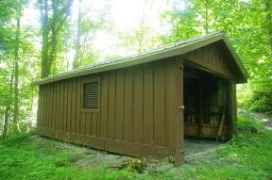
Charles Ashley Garage
Not evaluated | 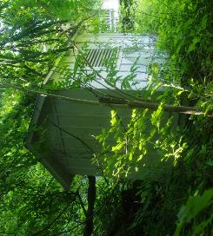
Charles Ashley Outbuilding
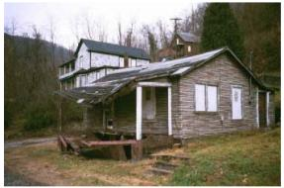 | 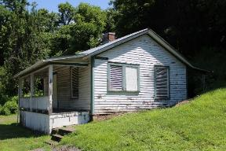
Marilyn Brown House
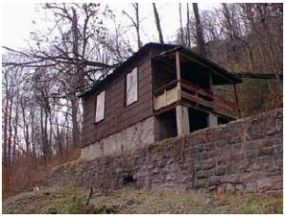 | 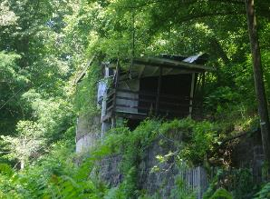
Erskine Pugh Rental House
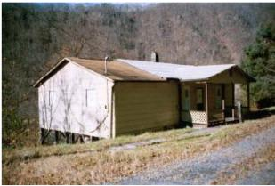 | 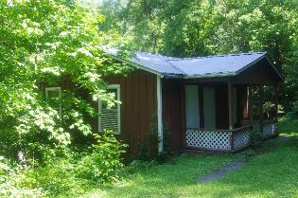
Harold Smith House
Not evaluated | 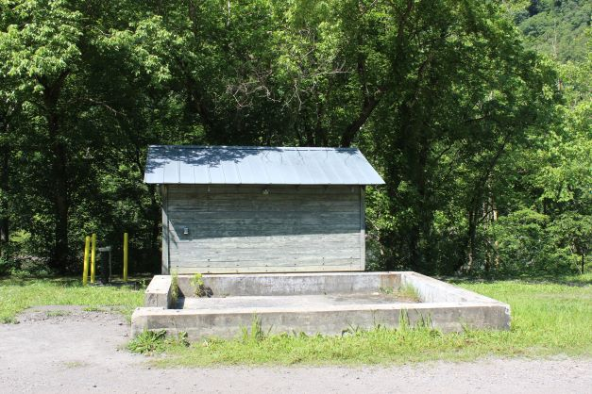
Ice House and original foundation
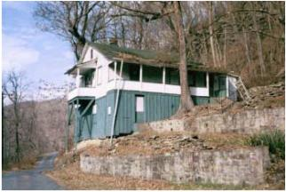 | 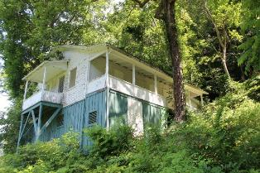
James Humphrey Sr. House
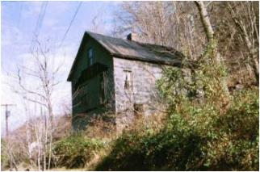 | 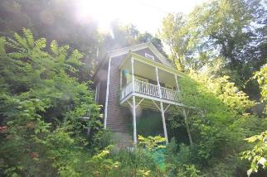
May Bagoski House
Not evaluated | 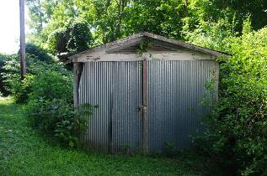
Billy McGuffin Garage
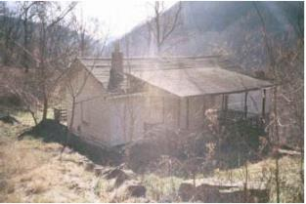 | 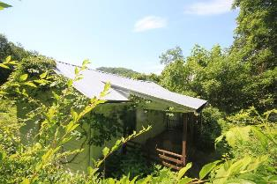
Phillip A. McClung House
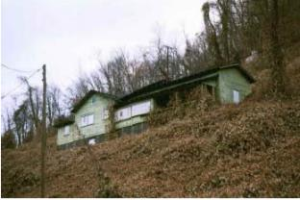 | 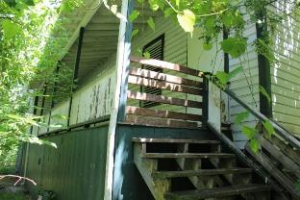
Tom Kelly House
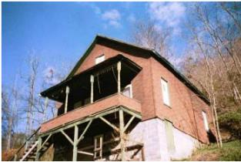 | 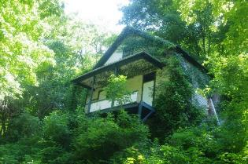
Wedzel Young House
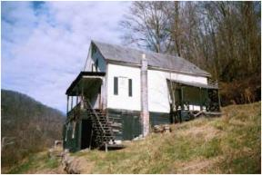 | 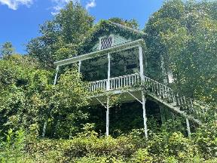
Sidney Allen Ward House
Table 5. Comparison of Selected Resources Between 2001 and 2022 in the Thurmond Historic District

Name | 2002 Evaluation | 2022 Field Observations
Charles Ashley Garage | N/A | Board-and-batten garage; roof and siding repaired since 2016. Good condition.
Charles Ashley Outbuilding | N/A | Small shed or outhouse; fair condition.
Marilyn Brown House | Poor condition. Collapsed front porch, poor roof condition, poor rear slope drainage. | Fair to good condition. Building has been repaired/stabilized but is showing wood deterioration near grade level as well as paint deterioration. Openings appear to be secure and vegetation is cleared.
Erskine Pugh Rental House | Poor condition; tree damage | Poor condition. Building was repaired and has since had another tree fall and cause roof damage. Significant deterioration in wood envelope, roof and foundation
Harold Smith House | Fair condition; ventilation and foundation improvements recommended | Repaired since 2002; fair condition. Some windows are missing allowing water and vandals to enter the building.
Ice House (Foundation) | N/A | Building relocated to this foundation in 1994 from original foundation 20’ to northeast. Appears to be in good condition.
James Humphrey Sr. House | Fair condition. Eroding slope, poor drainage, rear wall damage, porch and addition foundations shifting; all due to poor drainage and water control. | Building has been repaired since 2002 but is experiencing deterioration including missing and clogged gutters, vegetation, and dangerous tree/branches.
May Bagoski House | Poor condition. Missing front porch. Vegetation and poor drainage. | Good condition. Building was significantly repaired and restored since 2002. Reconstruction porch, asbestos siding removed, wood siding repaired/replaced.  Encroaching vegetation.
Billy McGuffin Garage | N/A | Deteriorating corrugated metal roof and walls. Encroaching vegetation.
Phillip A. McClung House | Poor condition. Multiple roof leaks, interior finish and floor damage, foundation instability. At severe risk of structural failure. | Poor condition. It appears that at least the roof was replaced by 2016. Almost totally covered by vegetation. Vines covered large portions of the wall and gutters. At least one window is completely open to the elements.
Tom Kelly House | Poor condition. Overgrown by kudzu. Failed roof, moisture penetration and almost total failure of floor structure. | Fair condition. Building has been restored since 2002. Heavy vegetation prevented detailed observation. Siding, roof and building envelop appear to be intact.
Wedzel Young House | Fair condition. Poor rear slope drainage and vegetation. Gutter failure and related roof deterioration. | Fair condition. Building has been repaired/ restored since 2002. Heavy vegetation and vines, missing front porch post and railing, detached gutters.
Sidney Allen Ward House | Fair condition. Minimal deterioration observed. Basic maintenance recommended. | Fair condition. Building has been repaired/ restored since 2002. Heavy vegetation and vines on house. Isolated deterioration of wood siding.
Table 6. Summary of Conditions and Maintenance Recommendations for Thurmond Resources

Conclusions
It is clear when comparing photographs from 2002 and 2016 that a significant amount of work and funding was dedicated to repairing, restoring and/or preserving many of the structures in Thurmond. The evolution of photos between 2002 and 2022 shows just how quickly nature can start to reclaim buildings without diligent and regular maintenance. The Thurmond Historic District has long been recognized as a valuable resource by the National Park Service at the local, regional and national levels. These condition observations and maintenance recommendations are presented to support and advance the National Park Service’s goal of responsible stewardship of cultural and historic resources.

Bibliography
“Batteaux on the New.” Web. National Park Service. January 26, 2021. https://www.nps.gov/neri/learn/historyculture/batteaux-on-the-new.htm.
Cohen, Stan. Where People and Nature Meet: A History of the West Virginia State Parks. Charleston, WV: Pictorial Histories Publishing Company, 1988.
Conley, Phil. History of the West Virginia Coal Industry. Charleston, WV: Educational Foundation, 1960. Accessed online at https://hdl.handle.net/2027/uiug.30112104644296.
De Feyter, Miles. “Whiteware Pioneer John Berry Passes Away.” Web. August 31, 2011. https://paddlinglife.com/paddling-life-exclusives/whitewater-pioneer-john-berry-passes-away/
Development Concept Plan, Interpretive Prospectus, Environmental Assessment: Grandview. United States: U. S. Department of the Interior, National Park Service, 1990.

Development Concept Plan/Interpretive Prospectus: Thurmond, New River Gorge National River, West Virginia. United States: U.S. Department of the Interior, National Park Service, Denver Service Center, 1992. Accessed online via Google Books.
Dixon, Thomas W. Jr. West Virginia Railroads Volume 2: Chesapeake & Ohio. TLC Publishing, 2011.
General Management Plan: New River Gorge National River, West Virginia. United States: U.S. Department of the Interior, National Park Service, Denver Service Center, 1982. https://parkplanning.nps.gov/document.cfm?parkID=259&projectID=28775&documentID=44823
General Management Plan: New River Gorge National River, West Virginia. United States: U.S. Department of the Interior, National Park Service, 2011. https://parkplanning.nps.gov/document.cfm?parkID=259&projectID=11040&documentID=61182
Good, Gregory A. and Lynn Stasick. New River Gorge National River Administrative History. United States: U.S. Department of the Interior, National Park Service, 2008. Accessed online at https://www.nps.gov/parkhistory/online_books/neri/neri_admin_history.pdf.
Harper, R. Eugene. National Register of Historic Places Inventory – Nomination Form: Thurmond Historic District. 1984. Document on file at the West Virginia State Historic Preservation Office, Charleston, WV. https://wvculture.org/wp-content/uploads/2021/03/Thurmond-historic-district.pdf
Harr, Milton. The C.C.C. Camps in West Virginia 1933-1942. Charleston, WV: Quarrier Press, 1992.

Marshall, Paul D. & Associates. A Cultural Resource Project: New River Gorge National River, WV. Report prepared for the National Park Service, 1984.

Miller, James H. History of Summers County, West Virginia: From the Earliest Settlement to the Present Time. Hinton, WV: Self-Published, 1908.

New River Gorge National River General Management Plan. Glen Jean, WV: U.S. Department of the Interior, National Park Service, 2011. https://parkplanning.nps.gov/projectHome.cfm?parkID=259&projectID=11040

Peters, J.T. and H.B. Carden. History of Fayette County, West Virginia. Charleston, WV: Jarrett Printing Company, 1926. Accessed online via Google Books.
Shepherd, William E., Sarah Duncan, and International Linear Parks Conference. “Concept Plan for the New River Parkway.” In Parkways, Greenways, Riverways: A Partnership for Beauty and Progress, 122–38. Appalachian State University, 1991. https://doi.org/10.2307/j.ctt1xp3n9z.19.
Thurmond Historic Structures Assessment, New River Gorge National River, West Virginia. Lowell, MA: National Park Service, Northeast Historic Preservation Center, 2002. https://www.quid-tum.com/documents/thurmond_assessment_report.pdf
Unrau, Harlan D. Special History Study/Historic Context Study: New River Gorge National River, West Virginia. United States: U. S. Department of the Interior, National Park Service, 1996.
Wild, Jay. “History of the Management Plan for the South Fork of the New River in N.C.” Proceedings of the New River Symposium, 1984. Web. https://www.nps.gov/parkhistory/online_books/symposia/newriver-84/sec15.htm
Wood, Jim. Raleigh County, West Virginia. Beckley, WV: Raleigh County Historical Society, 1994.
Young, Jay. Whitewater Rafting on West Virginia’s New & Gauley Rivers: Come On In, the Water’s Weird. Charleston, SC: History Press, 2011. E-book edition, 2013.

Appendix A
Project Area Maps

Appendix B
Historic Property Inventory Forms

Appendix C
PRoject Photographs

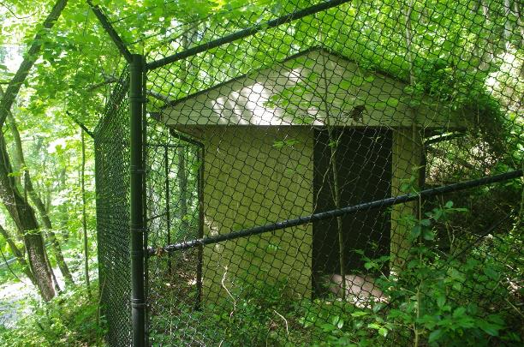
- Ajax Pump Building (FA-1023)
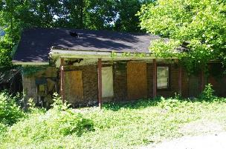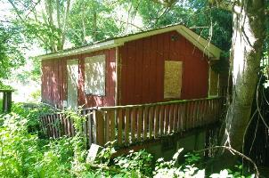
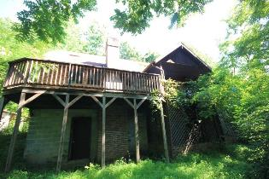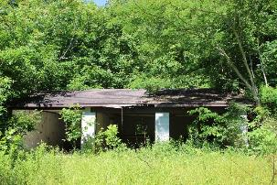
- Prince Residences, CW from top left: Billy Jo Adkins House (RG-0635), Jonny and Brenda Adkins House (RG-0636), Samuel Ames Garage (RG-0638), Samuel Ames House (RG-0637)
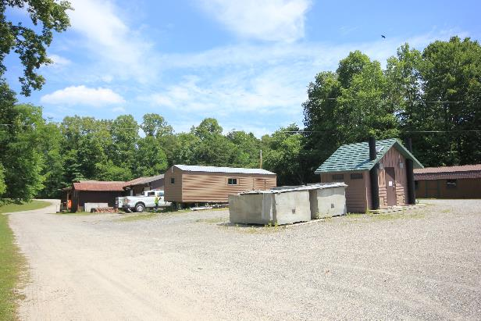
- Burnwood Area
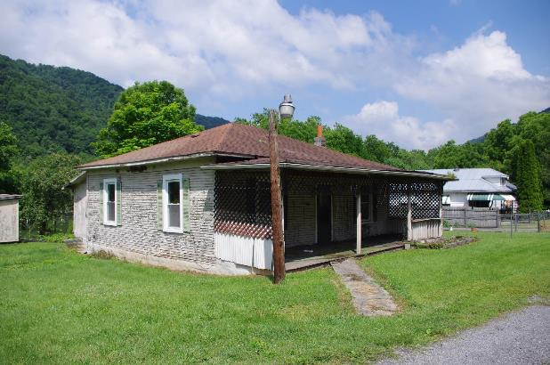
- Clarence Plumley House (SU-0520)

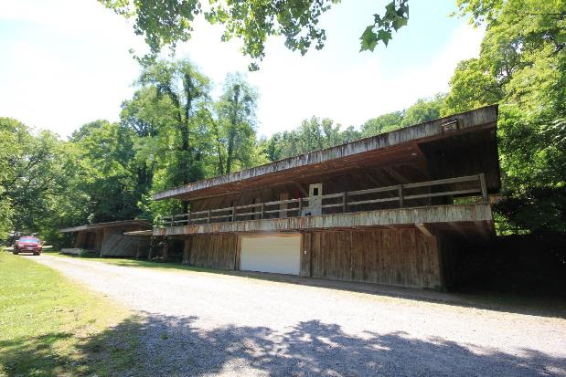
- Dun Glen/Wildwater Expeditions Unlimited Buildings from l: Mini-Ark (FA-1027),
Boat Storage Rack (FA-1030), Ark (FA-1028).
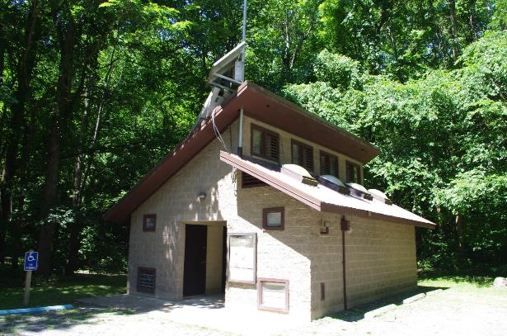
- Glade Creek Vault Toilet (RG-0634)
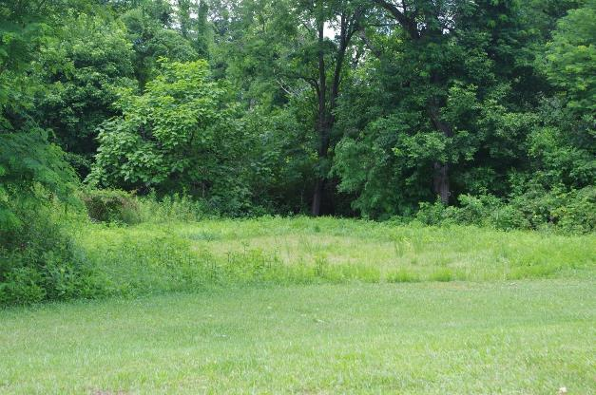
- Glenwood River Road Cabin area (buildings demolished.)
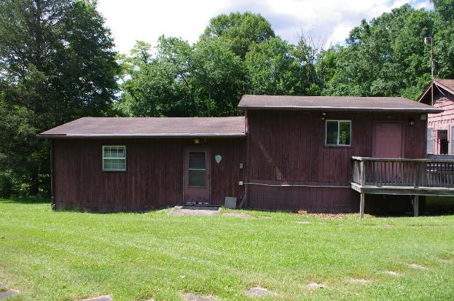
- Grandview Resource Stewardship Office/Ranger Cold Storage (RG-0639)
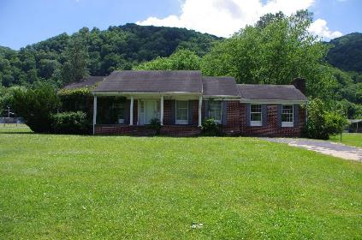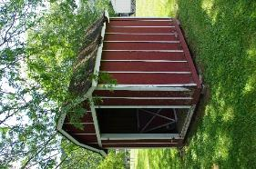
- Julian Mark Richmond House and Shed (RG-0640)
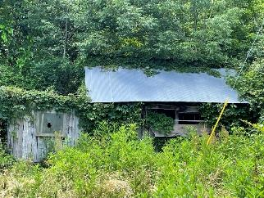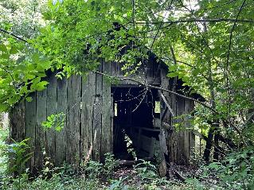
- Cochrane Farm Outbuildings #1 (RG-0627) and #2 (RG-0626)
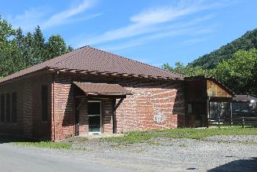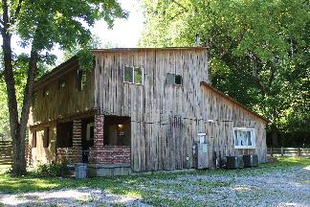
- Dun Glen Ranger Station (FA-0007-0016) and Dormitory/Powerhourse (FA-1029)
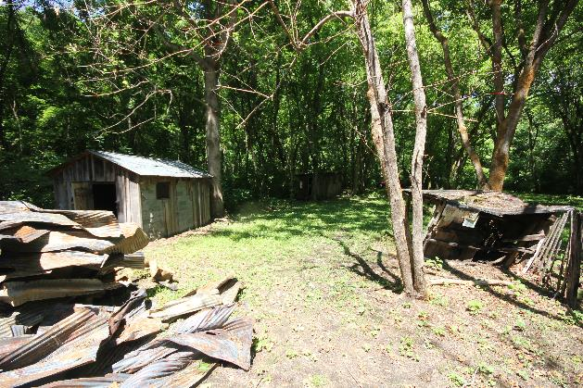
- Harrah Homestead House Ruins (RG-0628), Shed #1 (RG-0630) and Coal House (RG-0629)
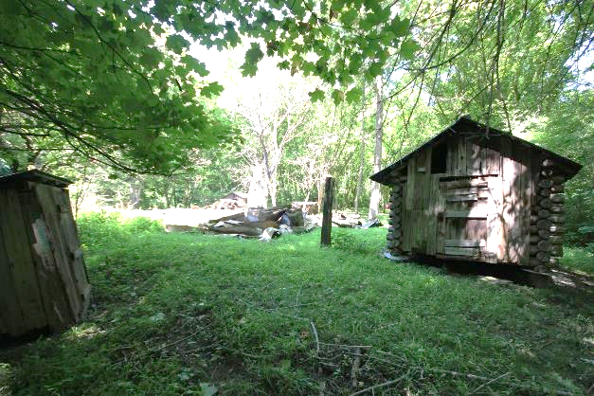
- Harrah Homestead Outhouse (RG-0633) and Smokehouse (RG-0623)
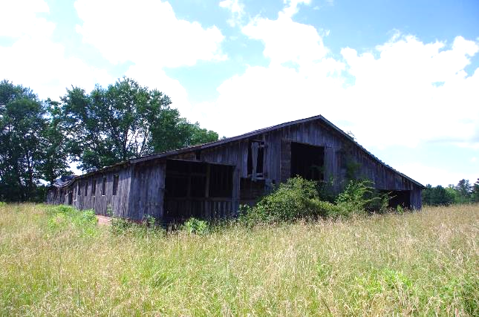
- James K. Carper Barn (RG-0623)
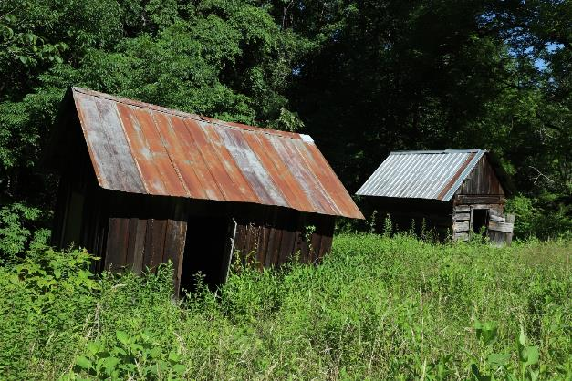
- James Phillips Storage Building #2 (RG-0624) and Outbuilding #1 (RG-0625)
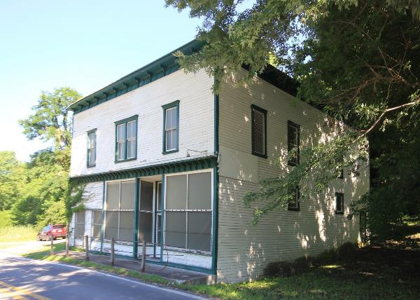
- Prince Brothers General Store
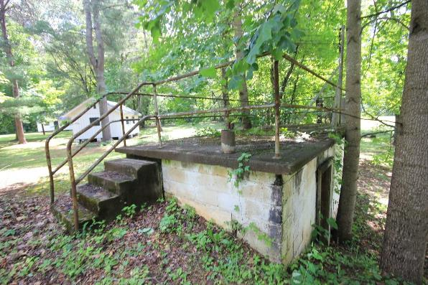
- Camp Brookside Pool Chemical Treatment Building (SU-0518)
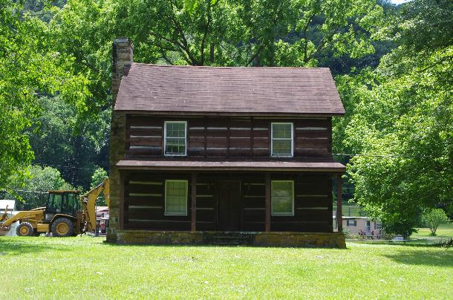
- Christiana and James Vallandingham House (RG-0307)
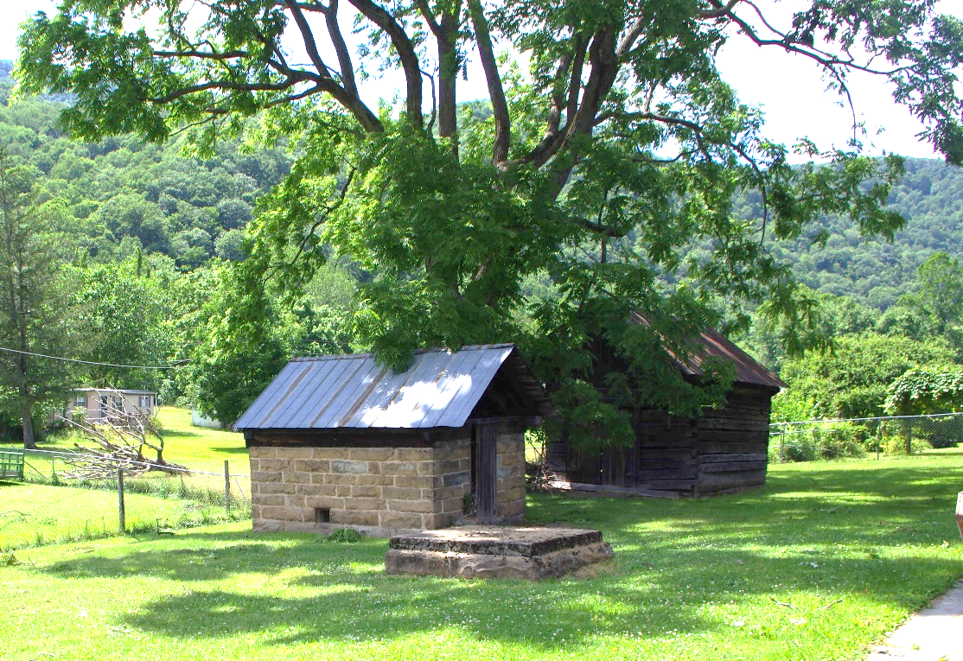
- Vallandingham wellhouse (l), well (center) and smokehouse (r)

Appendix D
NPS FMSS Numbers

NPS FMSS #’s
Name | FMSS No.
Ajax Mines Grounds | 3267
Ajax Pump Station Building | 3264
Billy Jo Adkins House | 237331
Burnwood Maintenance Storage Building | 3168
Burnwood Ranger Storage Building | 3166
Burnwood Ranger Storage Shed | 3165
Clarence Plumley House | 255105
Dun Glen Ark | 3367
Dun Glen Boat Storage/Emergency Cache | 3364
Dun Glen Boat Storage Rack | 3369
Dun Glen House/Dormitory | 3363
Dun Glen Mini Ark | 3368
Glade Creek Restroom | 3342
Glenwood Corp. River Road Cabins | 237296
Grandview Resource Stewardship Office | 3298
Jonny and Brenda Adkins House | 109457
Julian Mark Richmond House | 108942
Julian Mark Richmond Shed | 108943
Samuel Ames Garage | 237303
Samuel Ames House | 115637
Cochrane Farm Outbuilding #1 | 87598
Cochrane Farm Outbuilding #2 | 87599
Cochrane Farm Grounds | 4053
Dun Glen Building Ranger Station | 3361
Harrah Coal House | 87581
Harrah Hen House | 87584
Harrah House | 87604
Harrah Outbuilding #1 | 87582
Harrah Shed #1 | 87583
Harrah Smokehouse | 87585
Harrah Outhouse | 87620
James K. Carper Barn | 237310
James Phillips Farm House (collapsed) | 88106
James Phillips Farm Outbuilding #1 | 88105
James Phillips Farm Storage #2 | 88103
James Philips Farm Shed | 88104
Prince Brothers General Store | 3290
Camp Brookside Pool Chemical Treatment Building | 87630
Christiana and James Vallandingham Log Cabin House | 87590
Christiana and James Vallandingham Storage Building | 87589
Christiana and James Vallandingham Smokehouse | 87588
Thurmond Ice House | 87704
Erskine Pugh Rental House | 87708
Thurmond Charles Ashley Garage | 87691
Thurmond Charles Ashley Outbuilding | 87692
Thurmond Harold Smith House | 87696
Thurmond James Humphrey Sr. House | 97097
Thurmond Marilyn Brown House | 99932
Thurmond May Bagoski House | 87694
Thurmond Billy McGuffin Garage | 87705
Thurmond Philip A. McClung House | 87711
Thurmond Tom Kelly House | 87702
Thurmond Wedzel Young House | 87698

This structure is not listed as a contributing resource within the Thurmond Historic District.
The location of the structures within the NERI are identified on the maps found on pages 8-9.
Gregory Good and Lynn Stasick, New River Gorge National River Administrative History, 15.
Harlan D. Unrau. Special History Study/Historic Context Study: New River Gorge,119.
Unrau 119.
Thomas W. Dixon, Jr. West Virginia Railroads Volume 2: Chesapeake & Ohio.
Dixon.
Jim Wood, Raleigh County, West Virginia, 301.
Phil Conley, History of the West Virginia Coal Industry,202
J.T. Peter and H.B. Carden, History of Fayette County, West Virginia, 257.
Conley 207.
Peter 258.
Unrau 27.
Unrau 28.
Peters 270.
Wood 324
Wood 325.
Unrau 30.
Unrau 30.
Conley 210.
Wood 444.
Unrau 34
Unrau 138.
Unrau 144.
Stan Cohen, Where People and Nature Meet: A History of the West Virginia State Parks, 8
Cohen 8.
Milton Harr, The C.C.C. Camps in West Virginia 1933-1942.
Harr 149.
Development Concept Plan, Interpretive Prospectus, Environmental Assessment: Grandview, 8.
Unrau 148.
Wood 452.
Good 43.
Good 56.
Good 56
Wood 60.
Public Law 95-625. Title XI 92 STAT. 3544 https://www.govinfo.gov/content/pkg/STATUTE-92/pdf/STATUTE-92-Pg3467.pdf
General Management Plan Summary and Summary of Public Response to Draft Plan. New River Gorge National River, March 1983.
General Management Plan Summary.
Jay Young, Whitewater Rafting on West Virginia’s New and Gauley Rivers, 13-14.
Young 16.
Young 17.
Miles de Feyter, “Whitewater Pioneer John Berry Passes Away”, PaddlingLife.com, August 31, 2011.
Young 29.
99.
Thurmond Historic Structures Assessment, 2001-02.

